ADD Iteration 1: Establishing an Overall System Structure
In this first iteration for a greenfield system, the primary goal is typically establishing an overall system structure.

Step 1: Review Inputs (Design Drivers)
The architectural drivers for the design process include Architecturally Significant Requirements (ASRs) and the design purpose.
Input Type | Driver (Coalesce Project)
Design Purpose | Produce a sufficiently detailed design plan before implementation due to the complexity of the backend and API maintenance requirements.
Primary Functional Requirements (UCs) | UC-1 (Import Data from Multiple Sources), UC-2 (Set preferences for data), UC-3 (View aggregate step count in multiple ways), and UC-4 (Data pulled automatically).
Key Constraints (CONs) & Concerns (CRNs) | CON-1: API standards must be maintained. CON-2: User data must be secure. CRN-1: Some APIs may require frequent updates to keep the active key.
Quality Attributes (QAs) | QA-1: Ability to delete all data upon request. QA-2: Logging all actions for security verification.

Step 2: Establish Iteration Goal by Selecting Drivers
The goal of this iteration is to define the reference architecture and the overall system structure. The selected drivers influencing this high-level structure include the need to integrate multiple external services (Garmin, Google Fit, Coros, Apple) and the architectural concerns related to API volatility (CRN-1, CON-1).

Step 3: Choose One or More Elements of the System to Refine
Since this is the initial iteration of a greenfield project, the element chosen for refinement (through decomposition) is the entire FCAPS system (the 'Activity Consolidator' system).

Step 4: Choose One or More Design Concepts That Satisfy the Selected Drivers
The architects must identify alternatives and select concepts that address the drivers. The project documentation identifies Pipe and Filter and Repository as relevant architectural patterns/styles.
- Repository Architectural Pattern: This pattern is chosen because the system deals with generating and storing large volumes of data (health activities). The repository centralizes all data management, including user preferences (UC-2) and the logging requirements (QA-2). Centralization also helps manage consistency and security (CON-2).
- Pipe and Filter Architectural Pattern: This pattern is suitable for organizing the data flow, where inputs are processed in separate, sequential stages (filters). This is ideal for handling the process of importing data, normalizing it, and prioritizing it. The use of filters enhances Modifiability and Evolution (easy to add/change transformations), which is crucial given the volatility indicated by CRN-1 (frequent API updates).

Step 5: Instantiate Architectural Elements, Allocate Responsibilities, and Define Interfaces
Based on the chosen design concepts, key elements are instantiated and responsibilities are allocated:
Architectural Element | Design Concept Utilized | Key Responsibilities Allocated
Data Source Connectors (Filters) | Pipe and Filter | Implement UC-1 (Import Data) and UC-4 (Automatic Pull). Handle external API interaction (Garmin, Coros, Google Fit, Apple). Address CON-1 (API standards) and CRN-1 (API upkeep) by isolating external complexity.
Data Normalizer (Filter) | Pipe and Filter | Convert incoming data from various source connectors into a homogeneous format.
Prioritization/Combination Logic (Filter) | Pipe and Filter | Apply UC-2 rules to combine activities based on user preferences (source, time, activity).
Central Repository | Repository | Persistence and centralized storage of normalized data and user preferences. Enforce CON-2 (data security) and support QA-1 (data deletion) and QA-2 (action logging).
Client/Presentation Component | N/A (UI Focus) | Display combined activity data in the app or widget (UC-3).
In this initial iteration, specific functionality and interfaces are usually not precisely defined, but their eventual necessity is established.

Step 6: Sketch Views and Record Design Decisions
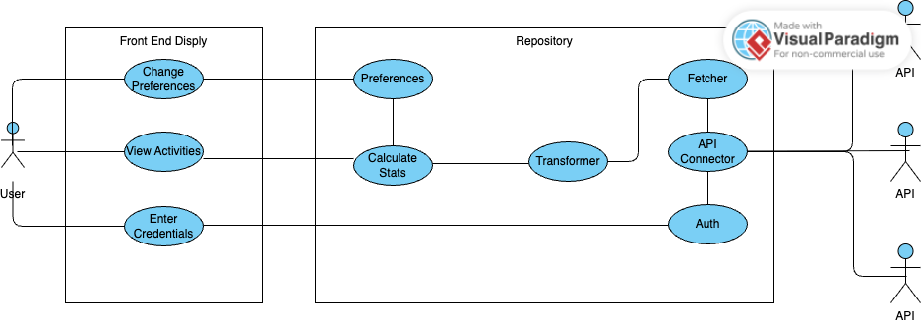

Step 7: Perform Analysis of Current Design and Review Iteration Goal
This step ensures the partial design addresses the established iteration goal and determines if the overall design purpose has been met or if further rounds are necessary.
- Review Goal Achievement: The iteration goal of establishing the overall system structure has been achieved by decomposing the system into major functional components (filters) and central data storage (repository).
- Analysis: The preliminary structure addresses the primary architectural concerns: complexity is managed by decomposition, and key quality attributes (data security, deletion) are assigned to the centralized Repository component. The core functionality (data pulling, normalization, prioritization) is accounted for in the filter pipeline.
- Conclusion: This initial iteration successfully established the architectural backbone. Further iterations are needed to refine interfaces, detail the internal workings of the filters, address specific technology selection, and refine how complex use cases (like UC-3, displaying data in widgets) are supported (analogous to Iteration 2 and 3 in the FCAPS design process).

Not Addressed | Partially Addressed | Completely Addressed | Design Decisions Made
UC-3: View aggregate step count in multiple ways (App, Widget, Notification) | UC-1: Import Data from Multiple Sources | QA-1: Ability to delete all data upon request | Architectural Patterns Selected: Pipe and Filter, and Repository were selected to govern the structure.
 | UC-2: Set preferences for data | QA-2: Logging all actions for security verification | Decomposition: The system was decomposed into functional components (Filters) and a central data hub (Repository).
 | UC-4: Data pulled automatically | CON-1: API standards must be maintained | Isolation of Complexity (CRN-1, CON-1): The Pipe and Filter pattern was adopted to isolate external API volatility (CRN-1) and manage API standards (CON-1) within separate Data Source Connector (Filter) components.
 | CON-2: User data must be secure | CRN-1: Some APIs may require frequent updates to keep active key | Centralized Data Management (QA-1, QA-2, CON-2): The Repository Pattern was chosen, and a Central Repository component was instantiated. This element is responsible for data persistence, fulfilling mandatory requirements for data deletion (QA-1) and comprehensive logging (QA-2).
 |  |  | Responsibility Allocation (UC-2): The establishment of the Central Repository (to store preferences) and the Prioritization/Combination Logic (Filter) (to apply preferences) provides the structural backbone for setting and applying data preferences (UC-2).

